Name : Shirsath Sanket Dilip
Class : TE Div : B Branch : COM
Roll No: 69
Assignment : Virtual Assignment 3
Title : Star Topology
Aim :
- To Construct Star Topology
Theory:
The word physical network topology is used to explain the manner in which a network is physically connected. Devices or nodes in a network get connected to each other via communication links and all these links are related to each other in one way or the other. The geometric representation of such a relationship of links and nodes is known as the topology of that network.
These topologies can be classifies into two types:-
1. Peer to peer
2. Primary - Secondary
Peer to peer is the relationship where the devices share the link equally. The examples are ring and mesh topologies.
In Primary - Secondary relationship, one device controls and the other devices have to transmit through it. For example star and tree topology.
Features of Star Topology:-
1. Every node has its own dedicated connection to the hub.
2. Hub acts as a repeater for data flow.
3. Can be used with twisted pair, Optical Fibre or coaxial cable.
Advantages of Star Topology:-
1. Fast performance with few nodes and low network traffic.
2. Hub can be upgraded easily.
3. Easy to troubleshoot.
4. Easy to setup and modify.
5. Only that node is affected which has failed, rest of the nodes can work smoothly.
Disadvantages of Star Topology:-
1. Cost of installation is high.
2. Expensive to use.
3. If the hub fails then the whole network is stopped because all the nodes depend on the hub.
4. Performance is based on the hub that is it depends on its capacity.

Procedure:
- The aim is to Create the topology.
- To perform the experiment follow the below steps
- A blank square area would be given which defines the working area
- A series of components would be given
- In order to build a topology first select on the component and then immediately click on the working area to place it
- To draw a line between two components first select the line click on the port of first component and then immediately click on the port of second component
- Once the topology is build then click on the Submit button to test whether the give topology is built correctly or not.
PRE TEST:
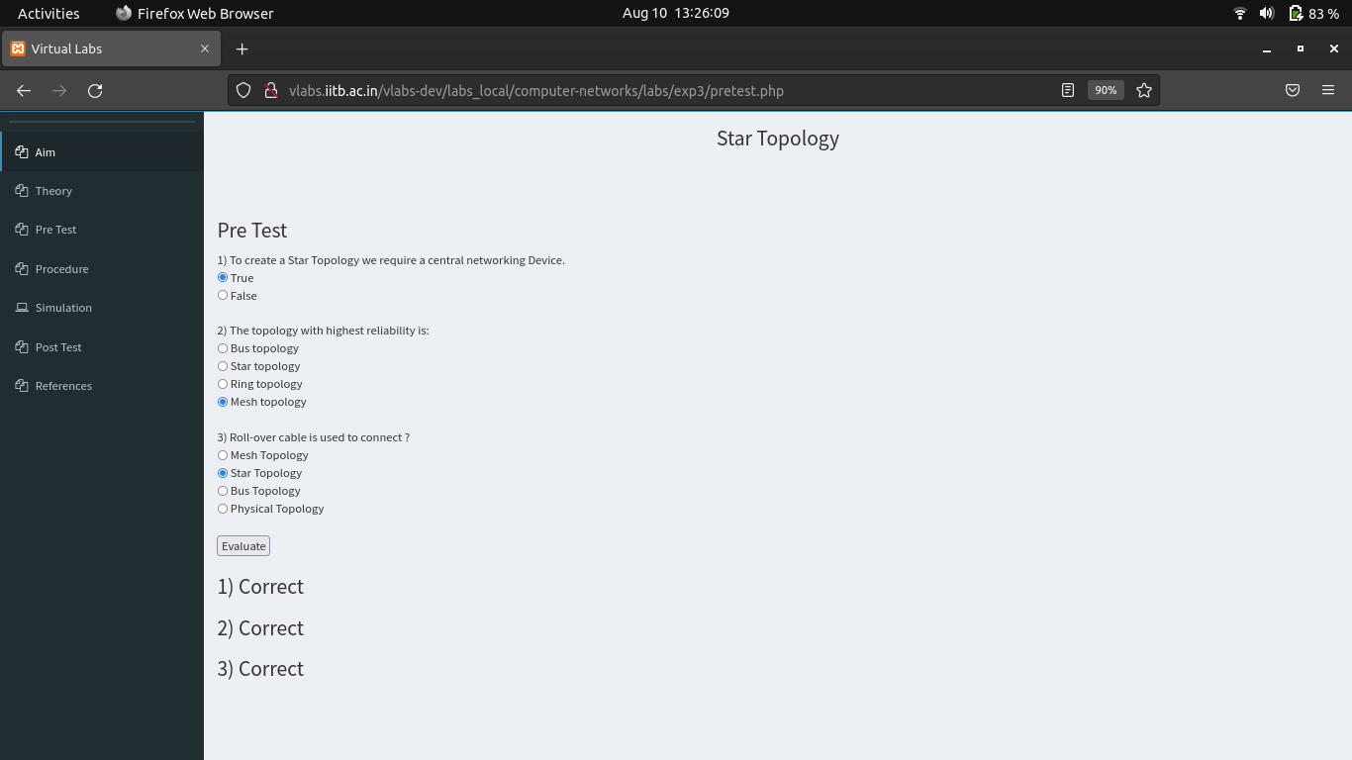
OUTPUT :
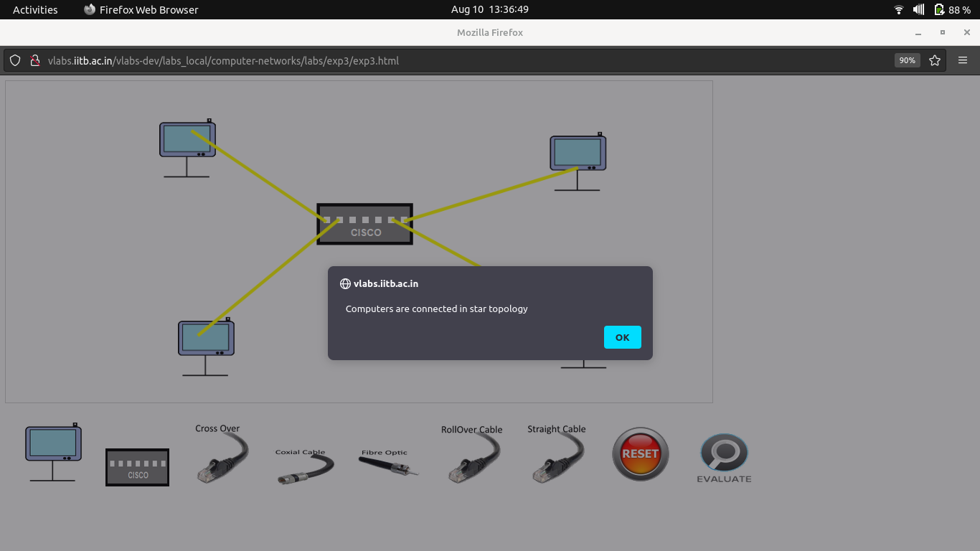

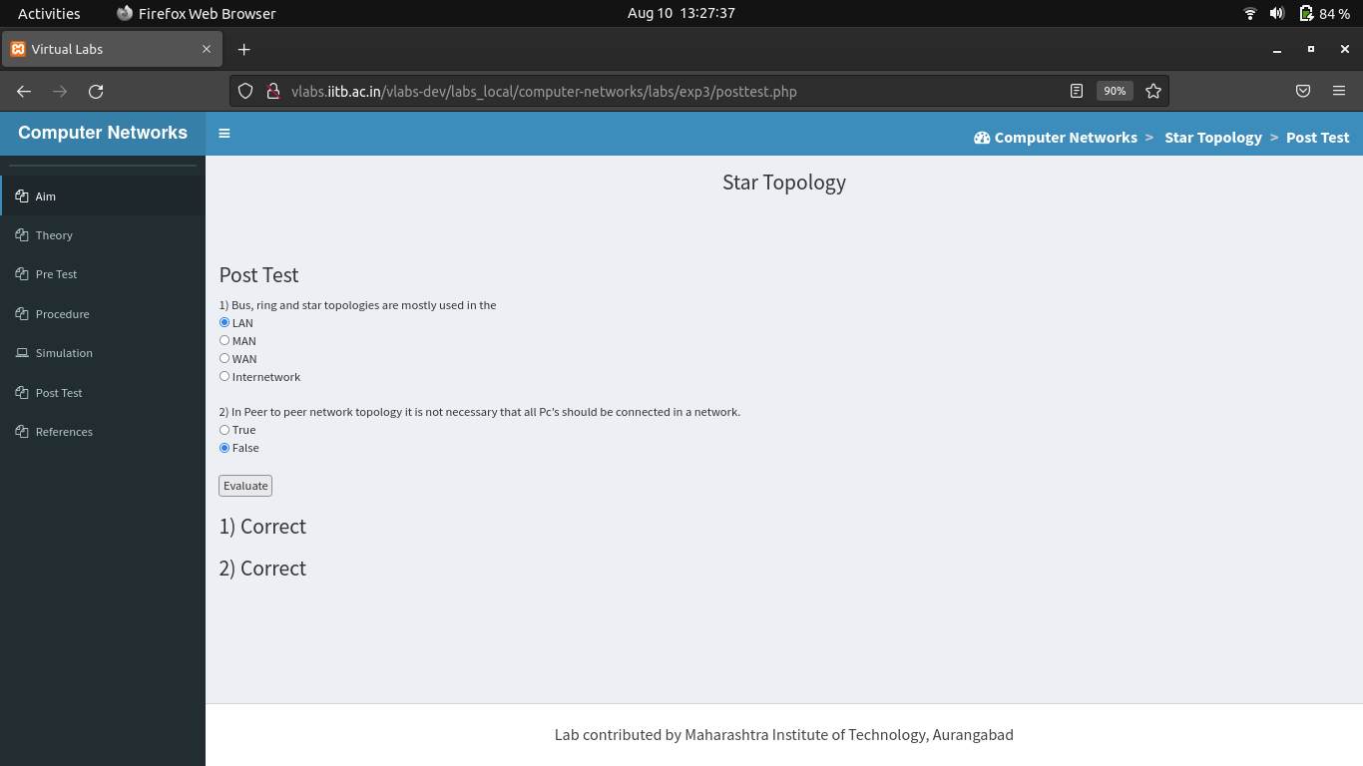
POST TEST:

